=Press release=
Sinot Yacht Architecture & Design presents:

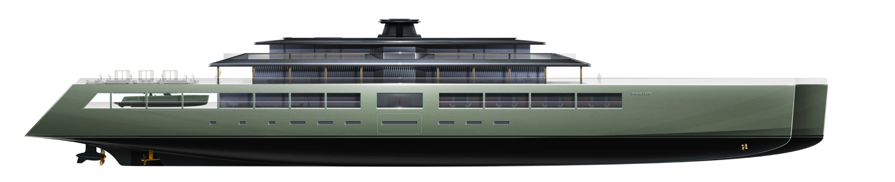
The world’s largest full-length trimaran superyacht concept
FUSION: 118 metres of architecture uniting culture, wellness, sports and exploration

Monaco, September 21 2026 – Sinot Yacht Architecture & Design proudly presents FUSION, the world’s largest full-length trimaran superyacht concept. Measuring 118 metres in length and 30 metres across, FUSION unites two worlds within one architecture: one driven by culture and wellness, the other by sports and exploration. Two 110-metre side hulls run almost the full length of the centre hull’s 115-metre waterline. Together, the centre hull and two near-full-length side hulls form a single, expansive architectural platform. FUSION combines exceptionally generous interior spaces with an unprecedented 3,340 m² of exterior deck space. This vastly increases the possibilities of life aboard: from art, music, wellness and gastronomy to diving, flying, water sports and expeditions to the world’s most remote places.
Sinot presents the ready-to-build, fully operational concept FUSION with a stunning 1.6-metre-long scale model at the Monaco Yacht Show 2026 (Stand: PP70 Parvis Piscine). More information and low-resolution and high-resolution images of FUSION can be downloaded directly from our press page: www.mi7.nl/sinot.
Design Vision FUSION: Two Worlds, One Architecture
FUSION’s three hulls come together as one architecture, creating the freedom to unite seemingly different worlds. On superyachts, owners traditionally must choose: a yacht designed mainly for entertaining rarely carries the volume, deck space or equipment for serious exploration. A true explorer platform, in turn, seldom offers the refinement and hospitality expected of a superyacht of this stature. FUSION’s trimaran architecture no longer asks owners to choose: three near-full-length hulls create a single platform broad enough to hold both worlds at full scale, rather than a reduced version of each.
FUSION is designed for both, with no compromises. An extensive gym and health area, 300 m2 spa and wellness centre, large cinema lounge and mission room, grand dining lounge and an expansive Owner’s Residence, alongside generous accommodation for 16 VIP guests, coexist with comprehensive facilities for serious exploration and adventure, with several spaces conceived to serve both worlds.
Across its 3,340 m² of exterior deck space, FUSION can accommodate an exceptional range of tenders, watercraft, submersibles, small aircraft, vehicles, and VTOL craft, extending life aboard far beyond the boundaries of the yacht itself by providing access to the sea, the air and places otherwise difficult to reach.
Culture and adventure, serenity and action, intimacy and openness all find their place within one architecture. That is the essence of FUSION: the freedom not to choose between different ways of living, but to embrace them all.
FUSION Exterior: Monumental Clarity
FUSION’s pure geometry, clarity of design and absence of unnecessary lines create a strong, monumental presence that sets it apart from its nautical peers.
Aft, the centre hull opens to reveal a concealed beach at lower-deck level, providing direct water access for diving and water toys. From the two side hulls, protected staircases lead to the Main Deck and its expansive tender, craft and vehicle deck.
Above, approximately 2,200 m² of Upper Deck exterior space accommodates an expansive pool terrace aft, while helicopter and VTOL landing zones, outdoor sports and large-scale gatherings are located on the forward section. Crowning FUSION is the Owner’s Deck, with the wheelhouse forward and the private Owner’s Residence aft, offering uninterrupted views over the wake and a private terrace of 100 m².
FUSION’s Staircase Lobby: The Architectural Heart
At the architectural heart of FUSION is the central staircase lobby, defined by a monumental transverse staircase. As it rises through the three upper decks, the staircase splits into different flights, connecting the forward and aft spaces aboard.
The steps unfold around a freestanding art installation that embodies the concept of fusion, bringing together internally illuminated glass and segments of handcrafted natural stone. The restrained lobby interior, with subtly textured natural stone panelling, provides a calm counterpoint to the strong diagonal lines of the staircase.
At Main Deck level, a second installation is positioned behind the elevator enclosure. Spanning the full 2.6-metre interior height, solid cast-glass sheets capture the image of an eruption of water, frozen in motion. Echoing the endless movement of the waves outside, the installation sets its structured transparency against the fluidity of the ocean, drawing artwork, light and seascape into one composition.
FUSION Owner’s Residence: Serenity on the Central Axis
An essential minimalist approach creates an atmosphere of serenity within the Owner’s Residence, softened by intricate handcrafted patterns across walls and ceilings. Travertine and natural woods dominate, accented by hand-selected, richly veined stone.
At its heart, the State Room is positioned on the yacht’s central axis, beyond His and Hers bathrooms and dressing rooms, a private lounge and desk area. The custom-designed king-size bed sits beneath a skylight with integrated shades and faces directly towards the 100 m² private exterior deck. Views over FUSION’s wake and the shifting horizon create a powerful connection with the surrounding seascape, while maintaining the intimacy of a private retreat.
Generously proportioned dressing rooms and bathrooms complete the residence. Showers positioned directly against the floor-to-ceiling glass façade turn everyday rituals into an immersive experience of sea, sky and changing light. Expansive vanities with integrated basins and a make-up area are sculpted from expressively veined natural stone, contrasting with the strong, minimal architecture.
FUSION’s Gym & Health Centre: Movement, Light and Sea
Forward on the Upper Deck, FUSION houses an extensive Gym & Health Centre, combining a temperature-controlled counter-current swimming pool with gym equipment arranged on dedicated platforms, treatment rooms for massage and physiotherapy, and comfortable lounge seating for relaxation and green tea ceremonies. The open-plan spaces maintain an uninterrupted visual connection with the surrounding sea through floor-to-ceiling glass façades.
Towards the bow of the centre hull, a large sliding section of the façade opens directly onto a sheltered platform for yoga, Pilates and sun salutations. Extended roof overhangs provide shade throughout the day, incorporating internally illuminated timber-beam structures that create a warm ambient light after sunset.
Beyond lies the exceptionally large 770 m² foredeck, the ‘Playdeck’, conceived as a flexible space for outdoor sports and activities. A full-size tennis court can be deployed, with the space equally suited to futsal, volleyball or even BMX. When not occupied by helicopter or VTOL operations, the Playdeck transforms into an expansive open-air arena for sport and recreation, or an extraordinary setting for live music, DJ performances and open-air art festivals.
FUSION’s VIP Rooms: Space, Privacy and Immersive Views
Located on the Main Deck, FUSION’s eight VIP rooms accommodate 16 guests and offer an exceptional sense of space and privacy. Each is organised around a central zone incorporating the dressing area, bathroom and bed, with passageways along both sides. The rooms extend into private 12 m² loggias with glass transoms, creating an uninterrupted connection with the sea and immersive views directly from the bed. Two VIP rooms also feature a private sauna.
The material language is pure and minimal, juxtaposing monumental natural stone with smoked glass and delicate latticework that filters light and views. Geometric forms define the shower and dressing areas, giving way to softer, more fluid forms around the bed, where handcrafted woods meet hand-woven carpets and upholstery fabrics. Fully custom-designed throughout, the interiors express fusion through grand architectural gestures and intricate detail.
FUSION’s Dining Lounge & Pool Terrace: Floating Between Sea and Sky
The Upper Deck Dining Lounge and its adjoining 970 m² pool terrace are a focal point for social life, bringing together gourmet dining and informal lunches with sunbathing, relaxation and large-scale pool parties. Inside, a generous dining table seats 18 guests. Two natural stone bars, with ten seats each, serve aperitifs, digestifs and refreshments throughout the day and evening.
The glass bottom of the 8.2-by-12.7-metre pool creates an intriguing, unexpected visual connection with the Main Deck below, where tenders and vehicles can be seen through the water. From below, the pool becomes a luminous ceiling; from above, its transparency creates an extraordinary sensation of floating between sea and sky.
Around the pool, custom-designed sun loungers and six shaded cabanas create settings for relaxation and socialising. Looking forward, the strong geometry of the pagoda-inspired roof structures of the Dining Lounge and Owner’s Deck provides shade and gives the terrace its distinctive architectural character. The terrace fuses an extraordinary openness to sea and sky with the privacy and seclusion of life aboard.
FUSION’s Cinema Lounge: Mission Room for Adventure
Using the deep overhangs of the deck above, FUSION’s Main Deck Cinema Lounge is a unique space aboard. Approached from the central staircase lobby through a monumental eight-metre-wide corridor, an oculus artwork, conceived as an ‘Eye in the Sky’, marks the entrance to a large cinema setting, where more than 20 guests can enjoy films and cinematic art on a 16 m² 8K MicroLED video wall.
The view outside is just as compelling. Floor-to-ceiling glass façades overlook FUSION’s vast 843 m² tender and vehicle deck, accommodating tenders, submersibles, water toys, and expedition vehicles. Directly below the glass-bottomed pool on the Upper Deck, filtered light and reflections from the water subtly illuminate favourite vehicles and tenders on display. Parallel travelling cranes, concealed within the ceiling structure, allow craft and equipment to be launched directly into the water or transferred to docks and jetties.
The Cinema Lounge therefore doubles as a gathering and briefing space for experiences that begin just outside its windows. Its large screen and advanced audiovisual systems can support preparations for scientific expeditions, treasure hunts, diving excursions or jetfoil competitions. Cinema, technology, exploration and the yacht’s collection of craft and vehicles come together on this deck, transforming the lounge into a mission room for adventure.
FUSION’s Spa & Wellness Centre: A World Apart
Deep within the aft of FUSION’s centre hull, an extraordinary 300 m² Spa & Wellness Centre, exceptional in scale even among the world’s largest superyachts, is conceived as a world apart. At its heart lies a circular inner sanctuary, where daybeds are arranged within a recessed floor section around a Foucault pendulum, whose slow movement marks the passage of time aboard. Subdued indirect lighting, semi-transparent latticework and backlit walls create an atmosphere of serene monumentality and intimacy.
The spacious, eight-metre-wide central corridor leads through a reception lounge, where comfortable seating faces a shallow water feature integrated into the floor. Large-scale artworks explore the tension between exertion and relaxation, while washrooms and changing rooms are positioned around the space. Further aft, semi-transparent lattice doors provide access to the inner sanctuary.
Beyond its backlit wall sections, a hammam, sauna, beauty and massage rooms, plunge pool and showers are discreetly integrated into the spatial composition. Throughout, monumental geometric clarity is fused with intricate detailing across walls, floors, ceilings and fully custom-designed furniture, creating a deeply contemplative environment for relaxation, rejuvenation and personal care.
FUSION Interior: Bespoke by Design
Every element of FUSION’s interior is designed for this yacht alone. Furniture, lighting, joinery, hardware and textiles are fully custom-designed by Sinot, and each can be adapted to the preferences of the future owner without compromising the architectural whole. The materials are always chosen for exceptional quality and rarity: precious natural stone, handcrafted woods, cast glass and hand-woven fabrics, sourced only from specialist ateliers that meet Sinot's responsible-sourcing requirements and traceable to their origin.
FUSION: Ready to Build
Over the past years, Sinot Yacht Architecture & Design has presented a series of high-profile concepts that have amazed, stimulated and inspired both clients and the market. Several of these concepts are in different stages of realisation. What all Sinot concepts have in common is that they combine an uncompromising design vision with proven engineering and practical, buildable solutions. FUSION is presented as a ready-to-build, fully operational concept: the trimaran platform, general arrangement and structural principles have been developed to a level that allows a shipyard to start detailed engineering without redesigning the concept.
Quotes Sander J. Sinot about FUSION:
“FUSION is not a standard yacht with extra stabilizers. Three near-full-length hulls come together as one architecture, and that changes what is possible aboard a yacht of this size.”
“Our owners no longer want to choose between culture and adventure, between serenity and action. FUSION is designed so they don’t have to.”
“With 3,340 square metres of exterior deck, the yacht stops being the boundary of life on board. The sea, the air and the places in between all become part of it.”
“The essence of FUSION is freedom: the freedom not to choose between different ways of living, but to embrace them all.”
Specifications FUSION
Overall length: | 118 m | Guest capacity: | Tenders and toys:
Length waterline: | 115 m | 18 persons: | 2 x 15 m limo tender
Beam overall: | 30 m | 1 Owner’s State Room | 2 x 15 m tender
Beam centre hull: | 17.5 m | 2 VIP State Rooms | Diver Equipment
Beam side hulls: | 4.7 m | 6 Guest State Rooms | Yacht Water Toys
Estimated GT: | 8,200 GT | 49 Staff, Crew, Captain | Expedition Vehicles
Naval Architecture in close cooperation with Azure Yacht Design & Naval Architecture

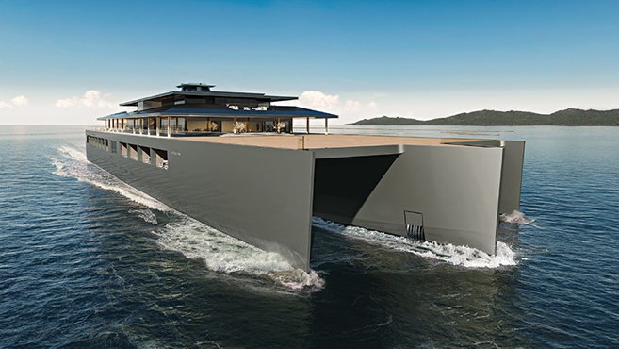SINOT MYS2026 FUSION Exterior front | 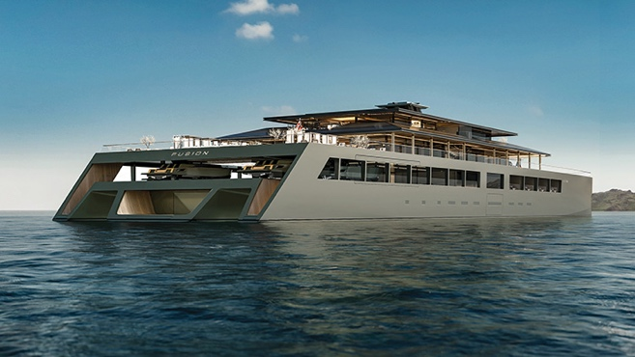SINOT MYS2026 FUSION Exterior aft low
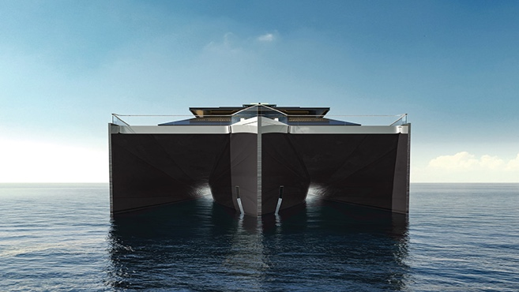  SINOT MYS2026 FUSION Exterior front low | 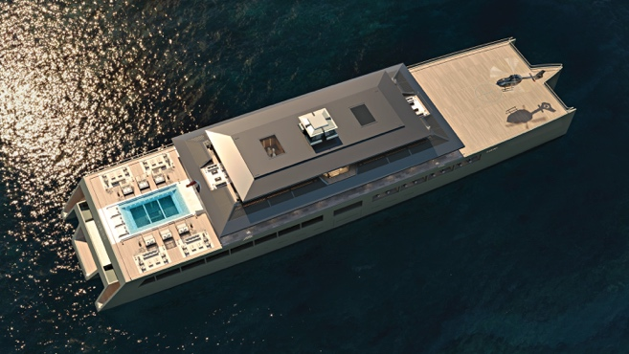SINOT MYS2026 FUSION Exterior top view
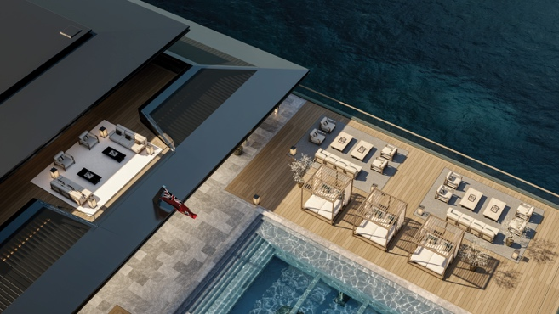SINOT MYS2026 FUSION Exterior UD terrace top | 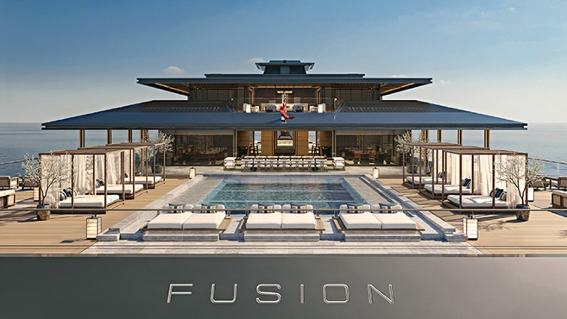SINOT MYS2026 FUSION Exterior UD terrace overview
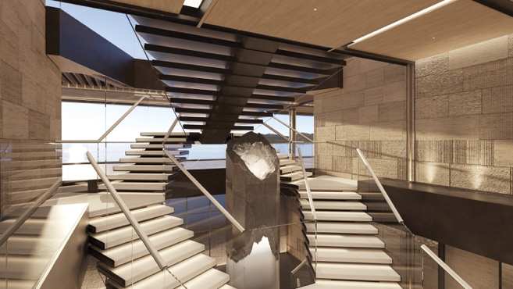SINOT MYS2026 FUSION UD Staircase Lobby Art | 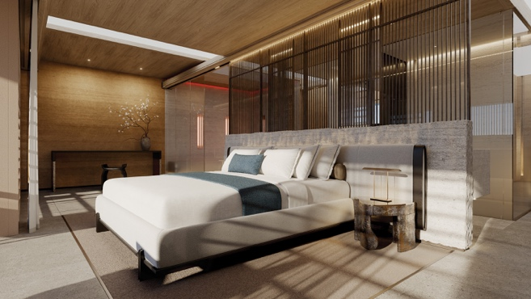SINOT MYS2026 FUSION MD VIP Bed
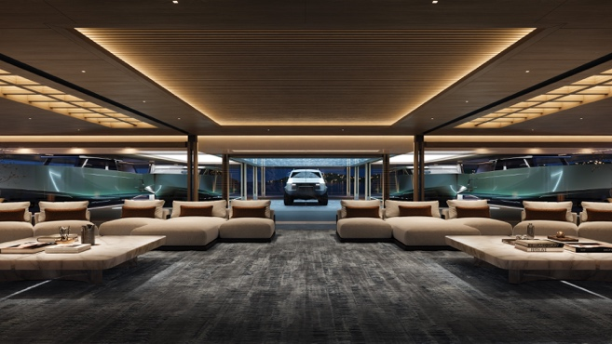SINOT MYS2026 FUSION MD Cinema Lounge view Garage | 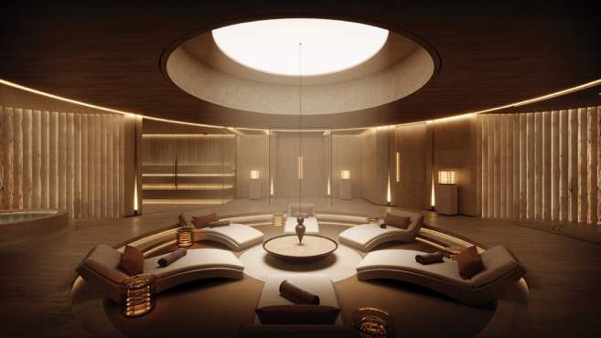SINOT MYS2026 FUSION LD Spa & Wellness sanctuary overview

Not for publication
Low-resolution and high-resolution of these and many more images of FUSION can be downloaded directly from our press page: www.mi7.nl/sinot. All images are free for editorial use, please use photo credit: Sinot Yacht Architecture & Design.
For more information please contact:
MI7 Media Intelligence, Mischa van de Woestijne, tel: +31 (0)6 2470 42 05, e-mail: mischa@mi7.nl

=End press release=

