=Press release=
=Updated Images=
Sinot Yacht Architecture & Design presents:
BEACH
The next step in comfort and flexibility
Eemnes / Palm Beach, March 22, 2023 – Sinot Yacht Architecture & Design is proud to present BEACH, a line of three distinctive superyachts in 77m, 88m and 99m LOA designs. This concept, developed to honour this year’s Dubai International Boat Show and Palm Beach International Boat Show, offers future owners a variety of yacht sizes as well as the opportunity to operate multiple yachts as a family or group of friends.
Design Vision BEACH
At the beach, you live in the present, follow the tides, and embrace the outdoors. It’s enough to bring about a feeling of tranquillity and revitalization. Designer Sander Sinot: “We named our new design concept BEACH, reflecting the clear connection with outdoor living and the idea of being close to the water in perfect harmony with the aquatic environment.” Each superyacht in the BEACH range has different functional options available in the General Arrangement, allowing owners to have a perfect match depending on their lifestyle and preferences. Sinot: “The beach theme is the basis for the interior style, while individual customization allows for a personal touch. Options and customization ensure private exclusivity for each yacht.”
Next level yacht design
The BEACH family of superyachts embodies the next step in comfort and flexibility. Where owners can choose a superyacht in the perfect configuration, or if they wish for several superyachts where privacy, functionality and comfort are key. Modern yacht design is the ethos of the BEACH yacht series. In addition to the clear lines and sculptural hull, construction is minimal and open. Balustrades are transparent and the connection with the water is all-encompassing, due to the floor-to-ceiling glass façades, a design element for which Sinot Yacht Architecture & Design is praised. The large exterior decks culminate in the aft deck beach, with an embedded infinity pool amid steps descending to the waterline. The beam-wide swim platform offers access to the water and acts as a mooring spot for private limo tenders and water toys. Sander Sinot: “A common theme of the BEACH series is the connection between the interior and exterior spaces aft. From the main lounge to the aft beach deck and on to the full beam beach club with fold-down hatches both on starboard and portside, there is a seamless transition to enjoy the pleasures of the sea and relish quality time with family and friends.”

A contemporary and refreshing approach to yacht interiors
The BEACH 77, 88 and 99 superyachts align with modern requirements, with full-beam forward owner’s state rooms, convertible cinema lounges, and multiple VIP and guest cabins. The uncluttered, open-plan layout maximizes available space onboard all yachts of the BEACH series, making them feel bright and breezy. The interior style is relaxed, informal, and open to individual accents in art, furniture, and color, accommodating an owner’s personal taste and style. The owner’s state room position can be changed with the position of the wheelhouse, and a central core setup within the owner’s area allows for a free walk-around inside the glass façade. VIP and guest cabins are based on requirements and there is a choice in beauty, treatment, gym, or spa facilities.
The uncluttered, open-plan layout maximizes available space onboard all yachts of the BEACH series, making them feel bright and breezy. Plentiful natural light from sea, skies, and views creates the feeling that there is no boundary between indoors and outdoors. Owner and guests will find comfort in the unique and superior quality furniture pieces, combining refined natural and reclaimed materials with a seamless integration of technology.
Owner’s State Room: Openness and freedom
On the BEACH superyacht series, the prime location is reserved for the owner’s state room in the forward section of the owner’s deck, offering maximum privacy and majestic views forward. All aspects of the owner’s state room, from the bed design and accessories to the chairs and rug, are completely custom-designed and carefully crafted from genuinely sustainable natural materials. The state room is connected to the owner’s bathrooms and his and her dressing areas by stunning walk-through passageways on either side of the head-rest wall, inside the full height glass façade. The owner’s deck is designed for the exclusive use of the owner, providing a special deck for him or her and their loved ones to sail in full privacy and maximum comfort. His and her dressing units are located on port and starboard, offering ample storage space and the spacious bathrooms offer a minimalist, laid-back, yet luxurious, style.
All around the deck, floor-to-ceiling windows enhance the inside-outside connection and create an incredible impression of openness and freedom. The exterior forward deck features a private seating area for sunbathing and a large jacuzzi.
Main Lounge: Shared relaxation
As the gateway to the aft beach deck, the main deck lounge is the place for guests, family, and friends to gather and prepare for a new day of relaxation aboard a BEACH superyacht. Panoramic ocean views are spectacular due to the full height glass façade and the glass balustrade. The relaxing lounge setting ensures this area of the yacht is ideal for spending memorable times with family and friends, establishing the lounge as a true meeting point of the yacht in an atmosphere of genuine hospitality.
Beach Club: Enjoy quality time
The Beach Club on the lower deck of the BEACH superyacht series is a multi-purpose space. With its direct access to the exterior aft beach deck with infinity pool, sunbeds, and loungers as well as the main deck lounge, it is a unique social space to enjoy the company of family and friends. It is a perfect place to linger and come together prior to and after water sports, or to work-out or enjoy a beauty treatment, or just to have a good time. It allows larger groups, from the shore or other yachts, to join onboard and enjoy the ocean to the absolute fullest.
Ready to be build
Several concepts Sinot Yacht Architecture & Design has developed over the years are in different stages of realization. What all concepts have in common is that they combine proven techniques with exceptional and innovative design elements. In addition, every concept is ready to be built. The BEACH 77, BEACH 88 and BEACH 99 designs are united by a stepped aft deck with a large pool, which connects the main deck seamlessly to the water. All yachts of the series feature abundant outdoor space on all decks, with distinct exterior designs which are discerning and timeless.
State-of-the-art and practical design solutions are incorporated in each yacht of the series. Key characteristics include full-height glass façades at the higher deck cabins and lounges for open ocean views and maximized overall ceiling heights, ensuring generous interior space. The layout, furniture arrangements and sightlines are smart and effective, optimizing the value of each square meter of available space aboard.
Specifications BEACH Series
 | BEACH 77 | BEACH 88 | BEACH 99
Overall length: | 77m | 88m | 99m
Length waterline: | 76,3m | 87,5m | 98,2m
Beam moulded: | 13,4m | 14,5m | 15,6m
Estimated GT: | 2000GT | 2550GT | 3000GT

Not for publication
Low-resolution and high-resolution updated images of Beach can be downloaded directly from our press page: www.mi7.nl/sinot
All images are free for editorial use, please use photo credit: © Sinot Yacht Architecture & Design
For more information on Sinot Yacht Architecture & Design and BEACH during the Palm Beach International Boat Show 2023 please send an e-mail to: kim@sinot.com
For press enquiries please contact MI7 Media Intelligence, Mischa van de Woestijne, +31 (0)6 2470 42 05, e-mail: mischa@mi7.nl
If you publish on Sinot and BEACH, we appreciate if you let us know and send us a link and or hard copy of the publication to:
MI7 Media Intelligence, M. van de Woestijne, Sophialaan 3, 1075BL Amsterdam, The Netherlands.
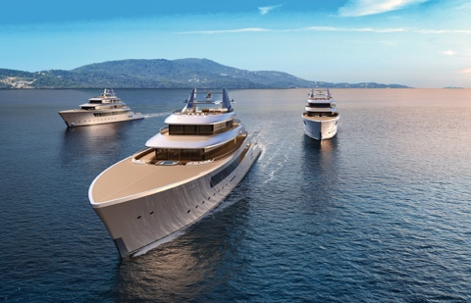 | 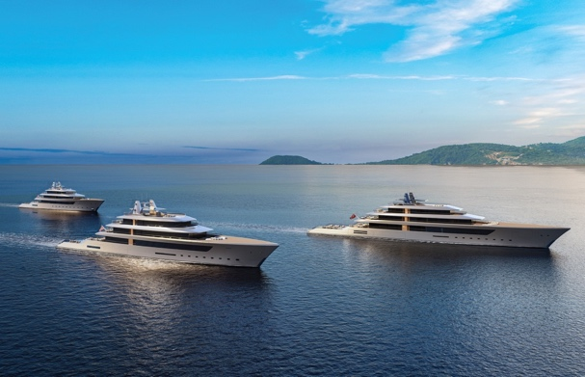
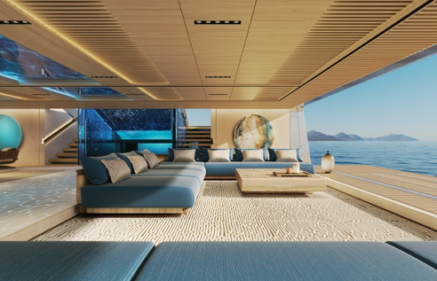 | 